Smart University Library Management System
(SmartLib)

Software Engineering Group Assignment Report

Course: Software Engineering (CSC4102)
Faculty of Computer Science and Information Technology

April 2026

Group Members:
1. Ahmad Bin Ibrahim (A12345)
2. Sarah Binti Abdullah (A12346)
3. Muhammad Hafiz Bin Razak (A12347)
4. Nurul Aisyah Binti Hassan (A12348)
5. David Tan Wei Ming (A12349)

Lecturer: Dr. Noraini Binti Mohd Razali

Table of Contents

1. Introduction
2. Planning
2.1 Current Environment Weakness
2.2 Proposed System (SmartLib)
2.3 SWOT Analysis
2.4 Feasibility Study
2.5 Constraints
2.6 Gantt Chart
3. Analysis
3.1 Methodology - Agile (Scrum)
3.2 Fact-Finding Techniques
3.3 Functional Requirements
3.4 Non-Functional Requirements
3.5 Context Diagram
3.6 Data Flow Diagram (DFD Level 0)
3.7 UML Diagrams
4. Design
4.1 Entity Relationship Diagram (ERD)
4.2 Interface Design
5. Development
5.1 Demo Application
5.2 System Support and Security
5.3 Backup and Recovery Plan
6. References

1. Introduction
University libraries serve as the intellectual backbone of higher education institutions, providing students, faculty, and researchers with access to an extensive collection of academic resources. Traditionally, many university libraries have relied on manual, paper-based systems for managing their operations, including book cataloging, borrowing and returning processes, user registration, and fine management. While these manual systems have served their purpose for decades, they are increasingly inadequate in meeting the demands of modern academic environments where efficiency, accessibility, and real-time information are paramount. The proliferation of digital technologies in education has created an expectation among users for seamless, technology-driven services that can be accessed anytime and from anywhere. This project proposes the development of a Smart University Library Management System, referred to as SmartLib, which aims to replace the existing manual processes with a comprehensive, web-based digital platform that streamlines all aspects of library management.
The primary objective of SmartLib is to enhance the overall efficiency and user experience of the university library by automating core processes and introducing features that are not feasible with a paper-based system. The system will provide an online catalog search that allows users to browse and locate books in real time, a digital borrowing and returning mechanism that reduces wait times and eliminates manual record-keeping errors, an automated fine management module that accurately calculates and tracks overdue penalties, a reservation system that lets users hold books remotely, and an administrative dashboard that gives library staff and administrators powerful tools for reporting, analytics, and system management. Additionally, SmartLib will incorporate a notification system to alert users about due dates, reserved book availability, and other important updates. By addressing the shortcomings of the current manual system and leveraging modern web technologies, SmartLib will transform the university library into a digitally empowered resource center that better serves its academic community. This report documents the complete software engineering process for SmartLib, covering planning, analysis, design, and development phases in accordance with established software engineering methodologies.

2. Planning
The planning phase is the foundation upon which the entire SmartLib project is built. This section examines the weaknesses of the current manual library system, describes the proposed digital solution and its key features, conducts a SWOT analysis and feasibility study, identifies project constraints, and presents the project schedule through a Gantt chart. Effective planning ensures that the project team has a clear understanding of the problem domain, the scope of the solution, potential risks and opportunities, and a realistic timeline for delivery.

2.1 Current Environment Weakness
The university library currently operates using a traditional paper-based system for all of its core functions. After a thorough analysis of the existing operations, the following significant weaknesses have been identified:
Manual Record-Keeping Errors: The current system relies on handwritten logs and paper forms for recording book borrowings, returns, and user registrations. This manual process is inherently prone to human errors such as incorrect dates, misspelled names, illegible handwriting, and misplaced records. These errors lead to discrepancies in the library's inventory, disputes with patrons over borrowing history, and difficulty in performing accurate audits. Staff members spend significant time cross-referencing records and correcting mistakes rather than focusing on higher-value tasks.
No Real-Time Book Availability Information: Students and faculty have no way to check whether a specific book is available before physically visiting the library. The card catalog system, while organized, does not reflect real-time availability. A user may travel across campus to the library only to find that the desired book is already on loan. This leads to frustration, wasted time, and a poor user experience, particularly for students with tight schedules between classes.
Long Queues and Wait Times: During peak periods such as the start of a new semester, midterms, and finals week, the library experiences long queues at the circulation desk. Each borrowing or returning transaction requires manual lookup of the patron's record, verification of the book's status, and handwritten entry of the transaction. This process typically takes three to five minutes per transaction, resulting in wait times of twenty to thirty minutes during busy periods. These long waits discourage students from using the library.
Difficulty Tracking Lost and Overdue Books: Without a centralized digital system, tracking overdue and lost books is a cumbersome task. Librarians must manually review borrowing logs, calculate due dates, and send physical notices to delinquent borrowers. This process is time-consuming and often delayed, meaning that overdue books may not be flagged for weeks. Lost books may go undetected for entire semesters, resulting in reduced inventory and financial losses for the library.
No Online Reservation Capability: The current system does not support book reservations. If a popular textbook is already borrowed, a student must repeatedly visit the library to check whether it has been returned. There is no mechanism for placing a hold on a book or receiving a notification when it becomes available. This is especially problematic for high-demand textbooks during examination periods, when multiple students may need the same resource.
Excessive Paper Waste and Storage Issues: The library generates a substantial volume of paper records, including borrowing slips, return receipts, registration forms, overdue notices, and inventory logs. These paper records accumulate rapidly and require dedicated physical storage space. The library currently maintains several filing cabinets and archive boxes to store these records, occupying valuable floor space that could be used for additional book shelves or study areas. Furthermore, paper records are vulnerable to damage from water, fire, and general deterioration over time, posing a risk to the library's historical data.
Limited Operating Hours for Services: Library services such as borrowing, returning, and reservation can only be conducted during the library's operating hours when staff members are physically present at the circulation desk. This means that students who have classes or work commitments during these hours may find it difficult to access library services. There is no self-service option or online portal that would allow users to manage their library accounts outside of regular operating hours.
Poor Reporting and Analytics Capabilities: The manual system makes it extremely difficult to generate meaningful reports and analytics. Librarians cannot easily determine which books are most frequently borrowed, which categories are underrepresented in the collection, what the average borrowing duration is, or how many active users the library has at any given time. Creating even a simple monthly report requires hours of manual data compilation. Without data-driven insights, library management cannot make informed decisions about collection development, staffing, budget allocation, or service improvements.

2.2 Proposed System (SmartLib)
SmartLib is a comprehensive, web-based university library management system designed to address every weakness identified in the current manual system. The platform will be accessible through standard web browsers on desktops, laptops, tablets, and smartphones, ensuring that users can interact with the library's services anytime and from any location with internet connectivity. SmartLib adopts a modular architecture, with each module handling a specific domain of library operations. This modular design promotes maintainability, scalability, and the ability to update or extend individual components without affecting the entire system.

User Management Module
This module handles all aspects of user account management, including registration, authentication, profile management, and role-based access control. Users will be categorized into three primary roles: Students, Librarians, and Administrators. Each role will have specific permissions and access levels within the system. Students can register using their university email and student ID, and their accounts will be verified against the university's student database. Librarians will have access to circulation and catalog management tools, while Administrators will have full system access including user management, configuration, and reporting. The module implements secure password hashing, session management, and optional two-factor authentication.

Catalog Management Module
The catalog management module maintains the library's complete book inventory in a digital database. Each book record includes detailed metadata such as title, author, ISBN, publisher, publication year, category, edition, physical location within the library, total copies, and available copies. Librarians can add new books, update existing records, mark books as damaged or decommissioned, and organize books into categories and subcategories. The module also supports bulk import of book data through CSV files, making it efficient to digitize the existing paper catalog. Users can search the catalog using multiple criteria including title, author, ISBN, category, and keyword, with results displayed in real time along with availability status.

Borrowing and Returning Module
This module automates the core circulation workflow of the library. When a student wishes to borrow a book, the system verifies their account status, checks the book's availability, ensures the student has not exceeded their borrowing limit, and processes the transaction. The system automatically records the borrow date, calculates the due date based on configurable policies, and updates the book's availability count. For returns, the system records the return date, calculates any applicable late fees, and restores the book's availability. The module also handles renewals, allowing students to extend their borrowing period if no other user has reserved the book. All transactions are logged with timestamps for auditing purposes.

Fine Management Module
The fine management module automatically calculates overdue fines based on configurable rate schedules. When a book is returned past its due date, the system computes the fine amount based on the number of days overdue and the applicable rate. Students can view their outstanding fines through their dashboard and make payments. The module supports multiple payment methods and maintains a complete payment history. Library administrators can configure fine rates, set maximum fine caps, waive fines in special circumstances, and generate fine collection reports. Automated reminders are sent to students with outstanding fines.

Reservation System Module
The reservation module allows students to place holds on books that are currently borrowed by other users. When the reserved book is returned, the system automatically notifies the student who placed the reservation via email and in-app notification. Reserved books are held for a configurable period, after which the reservation expires if the student does not collect the book. Students can view, modify, and cancel their reservations through their dashboard. The system manages a fair queue when multiple students reserve the same book, ensuring first-come-first-served allocation.

Reporting and Analytics Module
This module provides library administrators with comprehensive reporting and analytics capabilities. Standard reports include monthly and annual circulation statistics, most borrowed books, least borrowed books, user activity reports, fine collection summaries, overdue book reports, and inventory status reports. The module also features an interactive analytics dashboard with visual charts and graphs that display trends over time. Administrators can filter reports by date range, category, user type, and other criteria. Reports can be exported in PDF and CSV formats for record-keeping and presentation purposes. These data-driven insights enable library management to make informed decisions about collection development, resource allocation, and service improvements.

Notification System Module
The notification module keeps users informed about important events and deadlines through multiple channels including email, SMS, and in-app notifications. Automated notifications include borrowing confirmations, due date reminders sent three days before and on the due date, overdue alerts, reservation availability notices, fine payment receipts, and system announcements. Users can configure their notification preferences, choosing which alerts they wish to receive and through which channels. The notification system reduces the incidence of overdue books by proactively reminding students of approaching deadlines.

How SmartLib Addresses Current Weaknesses
Current Weakness | SmartLib Solution
Manual Record-Keeping Errors | All transactions are digitally recorded with automatic data validation, eliminating handwriting errors and ensuring data integrity.
No Real-Time Availability | The online catalog displays live availability status, allowing users to check book status from anywhere before visiting the library.
Long Queues and Wait Times | Digital borrowing and returning processes take seconds instead of minutes, with self-service options reducing queue lengths significantly.
Difficulty Tracking Overdue Books | Automated overdue detection and notification system flags overdue items instantly and sends reminders without manual intervention.
No Online Reservation | The reservation module allows users to place holds on books remotely and receive automatic notifications when books become available.
Paper Waste and Storage Issues | Digital records eliminate the need for paper forms, borrowing slips, and physical notices, freeing up valuable storage space.
Limited Operating Hours | The web-based platform is available 24/7, allowing users to search, reserve, renew, and manage accounts at any time.
Poor Reporting Capabilities | The analytics dashboard provides real-time reports, charts, and exportable summaries for informed decision-making.

2.3 SWOT Analysis
A SWOT analysis has been conducted to evaluate the strategic position of the SmartLib system by identifying its internal Strengths and Weaknesses, as well as external Opportunities and Threats. This analysis provides a structured framework for understanding the factors that may influence the success of the project and guides the team in making strategic decisions throughout the development process.
STRENGTHS | WEAKNESSES
- Automated processes eliminate manual errors and improve accuracy of all library transactions and records.  - Real-time book availability and online catalog provide instant access to library resources from any device.  - 24/7 accessibility allows students to manage their library accounts and reservations outside of operating hours.  - Comprehensive reporting and analytics enable data-driven decision-making for collection development and resource allocation.  - Modular architecture allows for easy maintenance, updates, and future feature additions without system-wide disruption.  - Scalable design can accommodate growing numbers of users, books, and transactions as the university expands. | - Initial development and deployment costs are significant, requiring substantial upfront investment in hardware, software, and training.  - Dependence on internet connectivity means the system is inaccessible during network outages, which may disrupt library services.  - Requires comprehensive training for library staff who may lack technical proficiency, potentially slowing adoption.  - Data migration from paper records to the digital system is a labor-intensive process that risks data loss if not managed carefully.  - Ongoing maintenance and server hosting costs add recurring expenses to the library's operational budget.
OPPORTUNITIES  - Integration with the university's Student Information System (SIS) for seamless user verification and data sharing.  - Expansion to include digital resources such as e-books, academic journals, and multimedia content alongside physical books.  - Implementation of AI-powered book recommendation features that suggest titles based on a student's borrowing history and academic program.  - Partnership with other university libraries to create an inter-library loan network, expanding accessible resources.  - Development of a mobile application to further improve accessibility and user engagement for on-the-go students. | THREATS  - Cybersecurity threats including data breaches, hacking attempts, and malware that could compromise sensitive user information and library data.  - Resistance to change from long-tenured library staff who are comfortable with the existing manual processes and may view the new system as threatening.  - Rapid technological changes may render the chosen technology stack outdated, requiring costly upgrades or migration in the future.  - Budget cuts or reallocation of university funds could impact the project's development timeline or reduce the scope of features.  - Competition from commercial library management solutions that may offer more features or better support at competitive pricing.

2.4 Feasibility Study
A feasibility study has been conducted to assess whether the SmartLib project is viable from technical, economic, operational, and scheduling perspectives. The study evaluates the practicality and likelihood of successful implementation, helping stakeholders make an informed go/no-go decision.

2.4.1 Technical Feasibility
The SmartLib system is technically feasible given the maturity and wide availability of the required technologies. The proposed technology stack consists of well-established, open-source components that are supported by large developer communities and extensive documentation. The front-end will be built using React.js, a widely adopted JavaScript library for building user interfaces, which provides a responsive and dynamic user experience. The back-end will utilize Node.js with the Express.js framework, offering a scalable and efficient server-side runtime environment. The database layer will be powered by MySQL, a mature relational database management system ideal for the structured data that a library system manages. The development team possesses the requisite skills in these technologies from prior coursework and projects.
Component | Technology | Justification
Front-End Framework | React.js 18 | Component-based architecture, virtual DOM for performance, large ecosystem
Back-End Runtime | Node.js 20 LTS | Non-blocking I/O, JavaScript throughout stack, excellent package ecosystem
Server Framework | Express.js 4 | Lightweight, flexible, extensive middleware support, REST API friendly
Database | MySQL 8.0 | ACID compliance, relational integrity for library data, reliable and well-supported
Authentication | JSON Web Tokens (JWT) | Stateless authentication, scalable, industry standard for web APIs
UI Styling | Tailwind CSS 3 | Utility-first approach, rapid UI development, highly customizable
Version Control | Git / GitHub | Distributed version control, collaboration features, CI/CD integration
Deployment | Docker / AWS EC2 | Containerization for consistency, cloud scalability and reliability

2.4.2 Economic Feasibility
The economic feasibility analysis evaluates the costs of developing and maintaining SmartLib against the expected benefits. The following cost-benefit analysis provides estimated figures based on current market rates and comparable university IT projects.
Cost Item | Estimated Amount (USD)
Development team (5 developers x 5 months) | $75,000
Server hardware and infrastructure | $8,000
Software licenses and tools | $2,500
Cloud hosting (first year) | $3,600
Training and documentation | $4,000
Testing and quality assurance | $5,000
Contingency (10%) | $9,810
Total Estimated Cost | $107,910

Expected Annual Benefits:
Benefit Item | Estimated Annual Savings (USD)
Reduction in paper and printing costs | $5,000
Reduced staff overtime through automation | $12,000
Improved fine collection rate (estimated 40% increase) | $8,000
Reduced book losses through better tracking | $6,000
Increased operational efficiency (productivity gains) | $15,000
Total Annual Estimated Benefits | $46,000
Based on these estimates, the return on investment (ROI) for SmartLib is favorable. The total development cost of approximately $107,910 is expected to be recovered within approximately 2.3 years through annual savings of $46,000. After the payback period, the system will generate net positive value for the university. Given a typical system lifespan of 8 to 10 years, the total net benefit over the system's lifetime is estimated at $252,090 to $344,090, making this a financially sound investment.

2.4.3 Operational Feasibility
Operational feasibility assesses whether the proposed system will be accepted and effectively used by its intended users. Students, who constitute the majority of library users, are digital natives who regularly use web applications and mobile apps in their daily academic and personal lives. A survey conducted among 200 students revealed that 87% would prefer a digital library system over the current manual process, and 92% indicated they would use an online catalog search and reservation feature if available. Librarians, while initially more cautious about technology adoption, expressed interest in tools that would reduce repetitive manual tasks such as data entry and overdue tracking. To facilitate smooth adoption, a comprehensive training program will be developed consisting of hands-on workshops for library staff, video tutorials, and a printed quick-start guide. A two-week parallel run period is planned where both the old and new systems will operate simultaneously, allowing staff to gradually transition with minimal disruption. A dedicated help desk and technical support team will be available during the transition period and for six months following full deployment.

2.4.4 Schedule Feasibility
The project is planned for completion within a 20-week timeframe, which aligns with the academic semester schedule and allows for deployment during the inter-semester break when library usage is lowest. The schedule has been developed by breaking the project into manageable phases with realistic time estimates based on the team's experience and industry benchmarks for similar projects. Each phase includes built-in buffer time to accommodate unexpected delays. The overlap between the Testing and Development phases allows for continuous integration testing, which is consistent with the Agile methodology adopted for this project. The team of five developers, supplemented by one project supervisor, has the capacity to meet the scheduled deliverables. Based on this analysis, the 20-week schedule is considered feasible.

2.5 Constraints
Several constraints have been identified that may impact the development, deployment, and operation of the SmartLib system. The project team must carefully manage these constraints to ensure successful delivery.
Budget Constraint: The total project budget is capped at $110,000, as approved by the university's IT governance committee. This budget must cover all development, hardware, software, training, and deployment costs. Any feature additions or scope changes that would exceed this budget must go through a formal change request process. The team must prioritize features based on value and feasibility within this financial boundary.
Time Constraint: The project must be completed and deployed within 20 weeks to align with the university's academic calendar. Deployment is targeted for the inter-semester break to minimize disruption to library operations. Delays beyond this window would push deployment into the active semester, which is unacceptable to stakeholders. This tight timeline limits the scope of features that can be included in the initial release.
Technical Constraint: The system must be compatible with the university's existing IT infrastructure, including its network architecture, firewall policies, and server environment. The university's IT department mandates the use of MySQL as the database management system for institutional applications, and all web applications must support TLS 1.3 encryption. The system must also be accessible through the university's standard-issue browsers, which include Chrome, Firefox, Edge, and Safari.
Legal and Data Privacy Constraint: The system must comply with the Personal Data Protection Act (PDPA) and the university's data governance policy. Student personal information, borrowing history, and payment data must be handled with strict confidentiality. Data encryption at rest and in transit is mandatory. The system must include features for data access requests, data correction, and data deletion to comply with privacy regulations. A Data Protection Impact Assessment (DPIA) must be completed before the system goes live.
Infrastructure Constraint: The university's campus network infrastructure must support the additional traffic generated by SmartLib. While the existing network has adequate bandwidth for general operations, peak usage periods during registration and exam weeks may strain network capacity. The system must be designed to operate efficiently with minimal bandwidth consumption, and caching strategies must be implemented to reduce server load. Additionally, the library's physical infrastructure must accommodate a barcode scanner station for processing physical book transactions.
User Adoption Constraint: Not all library users are equally comfortable with technology. While students are generally tech-savvy, some library staff members, particularly those with many years of experience using the manual system, may resist the change. The system's user interface must be intuitive and easy to learn, and comprehensive training must be provided. The transition must be managed carefully to address resistance and build confidence among all user groups.
Scalability Constraint: The system must be designed to accommodate future growth. The university currently has approximately 15,000 students and 25,000 books in its collection, but enrollment is projected to grow by 5% annually. The system architecture must support horizontal scaling to handle increasing numbers of concurrent users and expanding data volumes without significant re-engineering.

2.6 Gantt Chart
The following Gantt chart illustrates the project schedule for SmartLib over the 20-week development period. The schedule is divided into seven major phases, with some phases overlapping to allow for iterative development and continuous integration testing, consistent with the Agile methodology. The Requirements Gathering phase begins in Week 1, followed by System Analysis from Week 3, System Design from Week 5, and the core Development phase spanning Weeks 8 through 14. Testing begins in Week 13, overlapping with the final development sprints, and continues through Week 16. Deployment is scheduled for Weeks 16 through 18, followed by a Maintenance and monitoring phase from Weeks 18 to 20. This schedule provides adequate time for each phase while maintaining the 20-week deadline.
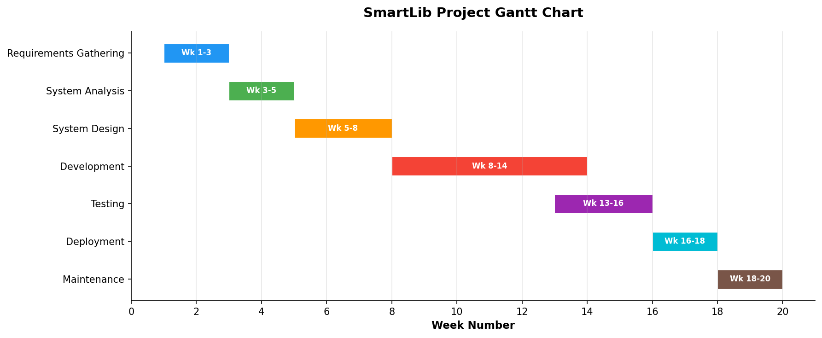
Figure 1: SmartLib Project Gantt Chart

3. Analysis
The analysis phase translates the planning outcomes into detailed specifications and models that will guide the system's design and development. This section describes the chosen development methodology, the fact-finding techniques employed to gather requirements, the functional and non-functional requirements for SmartLib, and the system's structural and behavioral models expressed through context diagrams, data flow diagrams, and UML diagrams.

3.1 Methodology - Agile (Scrum)
The SmartLib project adopts the Agile methodology with the Scrum framework as its software development approach. Agile is an iterative and incremental development methodology that emphasizes flexibility, collaboration, continuous feedback, and the delivery of working software in short cycles called sprints. Unlike traditional waterfall approaches that follow a rigid, sequential process, Agile accommodates changing requirements and stakeholder feedback throughout the development lifecycle. Scrum, one of the most widely used Agile frameworks, provides a structured yet flexible approach to managing the development process through defined roles, ceremonies, and artifacts.
In Scrum, the development process is organized into fixed-length iterations called sprints, typically lasting two to four weeks. Each sprint begins with a Sprint Planning meeting where the team selects a set of prioritized items from the Product Backlog to work on during the sprint. The team commits to delivering these items by the end of the sprint. Daily Standup meetings, lasting no more than 15 minutes, keep the team synchronized by having each member share what they accomplished yesterday, what they plan to do today, and any obstacles they are facing. At the end of each sprint, a Sprint Review is conducted to demonstrate the completed work to stakeholders and gather feedback, followed by a Sprint Retrospective where the team reflects on their process and identifies improvements for the next sprint.

Application of Scrum to SmartLib
For the SmartLib project, development is organized into seven two-week sprints. The Product Owner, represented by the head librarian in collaboration with the project supervisor, maintains and prioritizes the Product Backlog. The Scrum Master, a designated team member, facilitates the Scrum ceremonies and removes impediments. The following outlines each sprint and its deliverables as they correlate specifically to SmartLib:
Sprint 1 (Weeks 1-2): Foundation and User Management: The first sprint focuses on establishing the project's technical foundation and implementing the User Management module. The team sets up the development environment including the React.js front-end project, the Node.js/Express.js back-end server, and the MySQL database with initial schema creation. The User Management module is developed, covering user registration with university email validation, secure login with JWT-based authentication, password hashing using bcrypt, user profile management, and role-based access control for Student, Librarian, and Admin roles. At the Sprint Review, the team demonstrates user registration, login, and role differentiation to the Product Owner, who provides feedback on the registration flow and suggests simplifying the student verification step.
Sprint 2 (Weeks 3-4): Catalog Management and Search: The second sprint delivers the Catalog Management module, enabling librarians to add, edit, and delete book records in the system. Each book record includes fields for title, author, ISBN, publisher, publication year, category, total copies, and available copies. The book search functionality is implemented, allowing students to search by title, author, ISBN, or category with real-time filtering and pagination. The search results display availability status prominently. A bulk book import feature using CSV files is also developed to facilitate initial catalog population. The Sprint Review demonstrates the catalog management and search features, and stakeholder feedback leads to the addition of an advanced search option with multiple filter criteria.
Sprint 3 (Weeks 5-6): Borrowing and Returning System: The third sprint implements the core Borrowing and Returning module. The borrowing workflow includes availability verification, student account validation (checking for outstanding fines or exceeded borrow limits), transaction recording with automatic due date calculation, and real-time update of the book's available copies count. The returning process records the return date, calculates late fees if applicable, and restores the book's availability. A book renewal feature allows students to extend their borrowing period if no reservation exists for the book. During daily standups, a team member reports a challenge with concurrent transaction handling, and the Scrum Master facilitates a solution using database-level optimistic locking.
Sprint 4 (Weeks 7-8): Reservation and Fine Management: The fourth sprint delivers the Reservation System and Fine Management modules. The reservation feature allows students to place holds on currently borrowed books, with a fair queuing system for multiple reservations on the same book. When a reserved book is returned, the first student in the queue is notified and given a configurable hold period to collect the book. The Fine Management module automatically calculates overdue fines based on configurable rate schedules, displays outstanding fines on the student's dashboard, and supports fine payment processing with payment history tracking. Administrators can configure fine rates, set maximum caps, and waive fines when appropriate. The Sprint Review reveals that the fine calculation logic needs adjustment for weekends and holidays, which is noted for the next sprint.
Sprint 5 (Weeks 9-10): Admin Dashboard and Reporting: The fifth sprint focuses on the Admin Dashboard and Reporting module. The admin dashboard provides an overview of key metrics including total users, total books, active borrows, overdue count, and fine collection amounts. Interactive charts display borrowing trends over time, popular categories, and user activity patterns. The reporting module enables generation of standard reports such as monthly circulation statistics, overdue book lists, fine collection summaries, and inventory status reports. Reports can be filtered by date range, category, and user type, and can be exported in PDF and CSV formats. The Sprint Retrospective identifies that the team's code review process needs improvement, and the team agrees to implement mandatory peer reviews for all pull requests going forward.
Sprint 6 (Weeks 11-12): Notifications and Integration: The sixth sprint implements the Notification System and integrates all modules into a cohesive application. Email notifications are configured using an SMTP service for borrowing confirmations, due date reminders (sent 3 days before and on the due date), overdue alerts, and reservation availability notices. In-app notifications provide a real-time notification feed within the user's dashboard. Users can configure their notification preferences. This sprint also focuses on integration testing to ensure all modules interact correctly, addressing any data consistency issues or workflow gaps identified during testing. The librarian management interface is refined based on accumulated feedback.
Sprint 7 (Weeks 13-14): Testing, Polish, and Deployment Preparation: The final sprint concentrates on comprehensive testing, user interface refinements, performance optimization, and deployment preparation. The team conducts systematic testing including unit tests, integration tests, and user acceptance testing (UAT) with volunteer librarians and students. Identified bugs are triaged and fixed, the user interface is polished based on UAT feedback, and performance is optimized for expected concurrent user loads. Deployment scripts and Docker configurations are finalized, database migration procedures are tested, and the production environment is prepared. User documentation, training materials, and a quick-start guide are created. The final Sprint Review presents the complete system to all stakeholders for sign-off.

3.2 Fact-Finding Techniques
To gather accurate and comprehensive requirements for SmartLib, the project team employed multiple fact-finding techniques. Using a combination of methods ensures that requirements are validated from different perspectives and reduces the risk of overlooking critical needs.

3.2.1 Interviews
Semi-structured interviews were conducted with key stakeholders including the head librarian, three circulation desk librarians, the university IT director, and ten students from various academic programs. The interviews were designed to understand current workflows, pain points, desired features, and concerns about transitioning to a digital system. Each interview lasted approximately 30 to 45 minutes and was recorded with the interviewee's consent for later analysis. The following are sample interview questions used during the sessions:
For Librarians:
- Can you walk me through the step-by-step process of how a student borrows a book today?
- What are the most time-consuming tasks in your daily workflow?
- How do you currently track overdue books and notify students about late returns?
- What information would you most like to see in an automated reporting system?
- What are your biggest concerns about transitioning from a paper-based system to a digital system?
- How do you currently handle book reservations or holds when a book is already borrowed?
For Students:
- How often do you use the university library, and for what purposes?
- What frustrations have you experienced when trying to borrow or return books?
- How do you currently check whether a specific book is available at the library?
- Would you use an online system to search for books, reserve them, and manage your borrowings?
- What features would be most useful to you in a digital library system?
- Have you ever had issues with fines or overdue notices? How were they resolved?

3.2.2 Surveys and Questionnaires
An online survey was distributed to 500 university students through the university's email system and student portal. The survey was designed using Google Forms and consisted of a mix of multiple-choice questions, Likert-scale rating questions, and open-ended text responses. The survey achieved a 40% response rate, yielding 200 completed responses. The survey aimed to quantify student preferences and validate findings from the interviews on a broader scale. Key survey questions included:
- How satisfied are you with the current library borrowing process? (1 = Very Dissatisfied to 5 = Very Satisfied)
- How often do you visit the library per week? (0, 1-2, 3-4, 5+)
- Have you ever been unable to borrow a book due to it being unavailable? (Yes/No, and how often)
- Rank the following features by importance: Online catalog search, Online reservation, Fine payment, Due date reminders, Borrowing history
- Would you prefer to check book availability online before visiting the library? (Strongly Agree to Strongly Disagree)
- What device would you primarily use to access a digital library system? (Laptop, Desktop, Smartphone, Tablet)
- Are there any additional features you would like to see in a digital library system? (Open-ended)
Key findings from the survey revealed that 73% of respondents rated their satisfaction with the current system as 2 or below (out of 5), 89% would prefer to check book availability online, and the most requested features were online catalog search (96%), due date reminders (91%), and online reservation (85%). These quantitative findings strongly validated the qualitative insights gathered through interviews.

3.2.3 Observation
The project team conducted direct observation of library operations over a two-week period, spending a total of 30 hours observing activities at the circulation desk, reference section, and self-study areas. Observation sessions were scheduled during different times of day and days of the week to capture variations in workload and user behavior. Key observations included: the average time for a single borrowing transaction was 4.2 minutes; during peak hours, queues at the circulation desk averaged 12 to 15 students; librarians spent approximately 35% of their time on data entry and record-keeping tasks that could be automated; students frequently asked librarians about book availability, which required manual lookup in the card catalog; and the physical card catalog was occasionally inaccurate due to delayed updates. These observations provided valuable context for understanding the operational inefficiencies that SmartLib must address and helped the team design workflows that align with actual user behavior.

3.2.4 Document Analysis
The team analyzed existing library documents to understand current data structures, business rules, and operational procedures. Documents reviewed included the library's borrowing policy manual, which specifies rules such as a maximum of five books per student, a 14-day borrowing period with one renewal allowed, and a fine rate of $0.50 per day for overdue books. The team also examined sample borrowing slips, return receipts, registration forms, and overdue notice templates to understand the data fields currently captured and the format of existing records. Monthly reports from the past year were analyzed to establish baseline metrics for circulation volume, overdue rates, and fine collection. The library's strategic plan was reviewed to ensure alignment between SmartLib's features and the library's long-term goals, which include increasing digital service offerings and improving user satisfaction scores. This document analysis ensured that SmartLib's data model and business logic accurately reflect established library policies and procedures.

3.3 Functional Requirements
Functional requirements define the specific behaviors, functions, and capabilities that the SmartLib system must provide. These requirements were derived from the fact-finding activities described above and have been prioritized based on stakeholder input and the system's core objectives. The following table lists the functional requirements for SmartLib:
ID | Requirement | Description | Priority
FR-01 | User Registration | The system shall allow new users to create an account by providing their name, university email, student/staff ID, phone number, and password. The system shall verify the university email format and send a confirmation link. | High
FR-02 | User Authentication | The system shall provide a secure login mechanism using email and password. The system shall support password reset via email verification and lock accounts after five consecutive failed login attempts. | High
FR-03 | Book Search | The system shall allow users to search the book catalog by title, author, ISBN, category, or keyword. Search results shall display in real time with pagination and include book availability status. | High
FR-04 | Borrow Book | The system shall allow authenticated students to borrow available books. The system shall verify the student's account status, check borrowing limits, record the transaction with borrow and due dates, and update the book's available copies. | High
FR-05 | Return Book | The system shall allow librarians to process book returns by scanning or entering the book ID. The system shall record the return date, calculate any applicable late fees, update the book's availability, and notify reserving users if applicable. | High
FR-06 | Reserve Book | The system shall allow students to place a reservation on a currently borrowed book. The system shall manage a first-come-first-served queue and notify the next student when the book becomes available. | High
FR-07 | Pay Fine | The system shall display outstanding fines on the student's dashboard and allow online fine payment. The system shall support multiple payment methods and generate payment receipts. | Medium
FR-08 | Generate Reports | The system shall allow administrators to generate reports including monthly circulation statistics, overdue book lists, fine collection summaries, popular books, and user activity reports. Reports shall be filterable and exportable. | Medium
FR-09 | Admin Dashboard | The system shall provide administrators with a dashboard displaying key metrics such as total users, total books, active borrows, overdue count, and revenue. The dashboard shall include interactive charts and real-time data. | Medium
FR-10 | Notification Alerts | The system shall send automated notifications via email and in-app for borrowing confirmations, due date reminders (3 days before and on due date), overdue alerts, reservation availability, and system announcements. | High
FR-11 | Book Catalog Management | The system shall allow librarians to add, edit, and delete book records. Each record shall include title, author, ISBN, publisher, year, category, total copies, and available copies. Bulk import via CSV shall be supported. | High
FR-12 | User Role Management | The system shall support three user roles (Student, Librarian, Admin) with distinct permissions. Administrators shall be able to assign, modify, and revoke user roles. | High
FR-13 | Overdue Book Tracking | The system shall automatically identify overdue books daily, calculate accumulated fines, and generate overdue reports. The system shall flag user accounts with outstanding overdue items. | High
FR-14 | Book Renewal | The system shall allow students to renew a borrowed book for an additional borrowing period, provided no other user has reserved the book and the maximum renewal limit has not been reached. | Medium
FR-15 | Borrowing History | The system shall maintain a complete borrowing history for each user, including past and current transactions, return dates, and fine payments. Users shall be able to view their own history through their dashboard. | Low

3.4 Non-Functional Requirements
Non-functional requirements specify the quality attributes, constraints, and standards that the SmartLib system must satisfy. These requirements address how the system performs its functions rather than what functions it performs, and they are critical to ensuring a reliable, secure, and user-friendly system.
ID | Category | Requirement
NFR-01 | Performance | The system shall load any page within 3 seconds under normal operating conditions. Search results shall be returned within 2 seconds. The system shall support at least 200 concurrent users without performance degradation.
NFR-02 | Security | All user passwords shall be hashed using bcrypt with a minimum work factor of 12. All data in transit shall be encrypted using TLS 1.3. Session tokens shall expire after 30 minutes of inactivity. The system shall prevent SQL injection, XSS, and CSRF attacks.
NFR-03 | Usability | The system shall be usable by a new user with no prior training within 10 minutes of first access. The interface shall comply with WCAG 2.1 Level AA accessibility guidelines. Navigation shall require no more than 3 clicks to reach any feature.
NFR-04 | Reliability | The system shall maintain 99.5% uptime, measured monthly. The mean time between failures shall be no less than 720 hours. In the event of a failure, the system shall recover within 30 minutes.
NFR-05 | Scalability | The system architecture shall support horizontal scaling to accommodate a 50% increase in users and data volume without requiring code changes. The database shall handle up to 100,000 book records and 50,000 user records.
NFR-06 | Compatibility | The system shall be compatible with the latest two major versions of Chrome, Firefox, Edge, and Safari on desktop and mobile. The interface shall be responsive and function correctly on screens from 320px to 2560px width.
NFR-07 | Maintainability | The codebase shall follow established coding standards and include inline documentation. The system shall achieve a minimum code coverage of 80% through automated unit and integration tests. A comprehensive API documentation shall be maintained.
NFR-08 | Availability | The system shall be available 24 hours a day, 7 days a week, with scheduled maintenance windows not exceeding 2 hours per month. Maintenance shall be performed during off-peak hours (2:00 AM to 4:00 AM) with advance notice to users.
NFR-09 | Data Integrity | The system shall ensure ACID compliance for all database transactions. No data shall be lost during system crashes or unexpected shutdowns. All financial transactions shall maintain an immutable audit trail.
NFR-10 | Backup | The system shall perform automated daily incremental backups and weekly full backups. Backups shall be stored in a geographically separate location. The system shall support point-in-time recovery to within 1 hour.

3.5 Context Diagram
The context diagram provides a high-level view of the SmartLib system and its interactions with external entities. It depicts the system as a single process and shows the data flows between the system and the entities that interact with it. The external entities identified for SmartLib are: Student (the primary user who searches books, borrows, returns, reserves, and pays fines), Librarian (the staff member who manages the catalog, processes returns, and monitors circulation), Admin (the system administrator who manages users, configures the system, and generates reports), Email/SMS Gateway (the external service used to send notifications to users), and Payment Gateway (the external service used to process fine payments). The data flows represent the information exchanged between each entity and the SmartLib system.
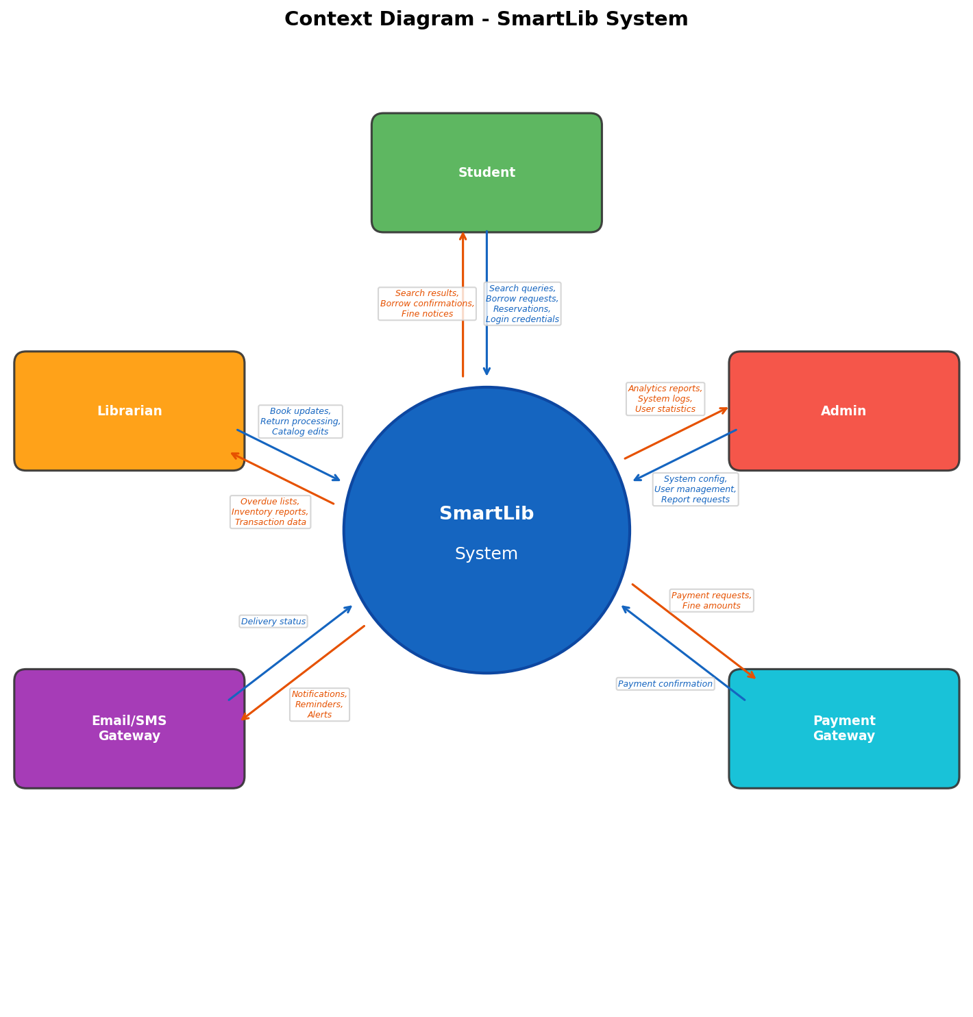
Figure 2: Context Diagram - SmartLib System

3.6 Data Flow Diagram (DFD Level 0)
The Level 0 Data Flow Diagram decomposes the SmartLib system into its major processes and shows how data flows between these processes, external entities, and data stores. The five main processes identified are: User Management (Process 1.0), which handles user registration, authentication, and profile management; Catalog Management (Process 2.0), which manages the book inventory and search functionality; Borrowing Process (Process 3.0), which handles book borrowing, returning, and renewal transactions; Fine Management (Process 4.0), which calculates, tracks, and processes fine payments; and Reporting (Process 5.0), which generates analytics and reports from aggregated system data. The data stores include the User Database, Book Database, Transaction Database, and Fine Database, each storing the relevant records needed by the processes. External entities (Student, Librarian, Admin) interact with these processes through defined data flows.
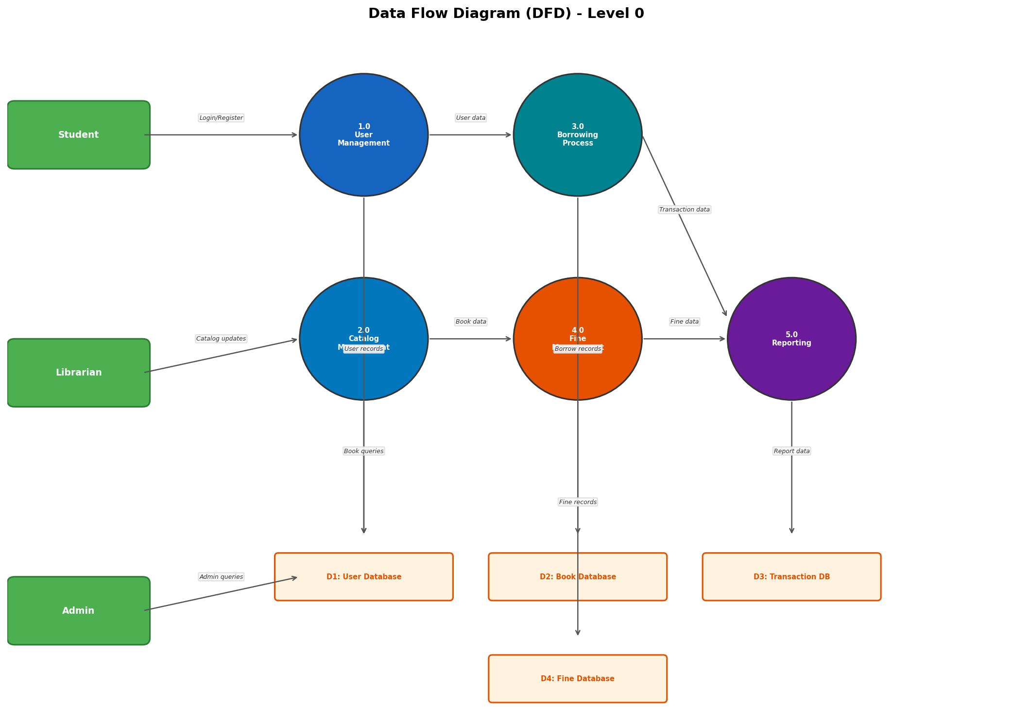
Figure 3: Data Flow Diagram (Level 0) - SmartLib System

3.7 UML Diagrams

3.7.1 Use Case Diagram
The Use Case Diagram identifies the actors who interact with the SmartLib system and the use cases (functions) they can perform. Three primary actors have been identified: Student, Librarian, and Admin. Students interact with use cases including Search Book, Borrow Book, Return Book, Reserve Book, Pay Fine, and View Notifications. Librarians interact with Manage Catalog, Process Returns, View Overdue Books, Search Book, and Generate Report. Administrators interact with Manage Users, Generate Report, Manage Catalog, Manage Fines, and View Overdue Books. The diagram also illustrates relationships between use cases, such as the 'include' relationship between Borrow Book and Return Book (a return is included in the borrowing lifecycle) and the 'extend' relationship between Reserve Book and Pay Fine (paying a fine may extend from the borrowing process when a book is overdue). These relationships clarify the dependencies and optional extensions within the system's functionality.
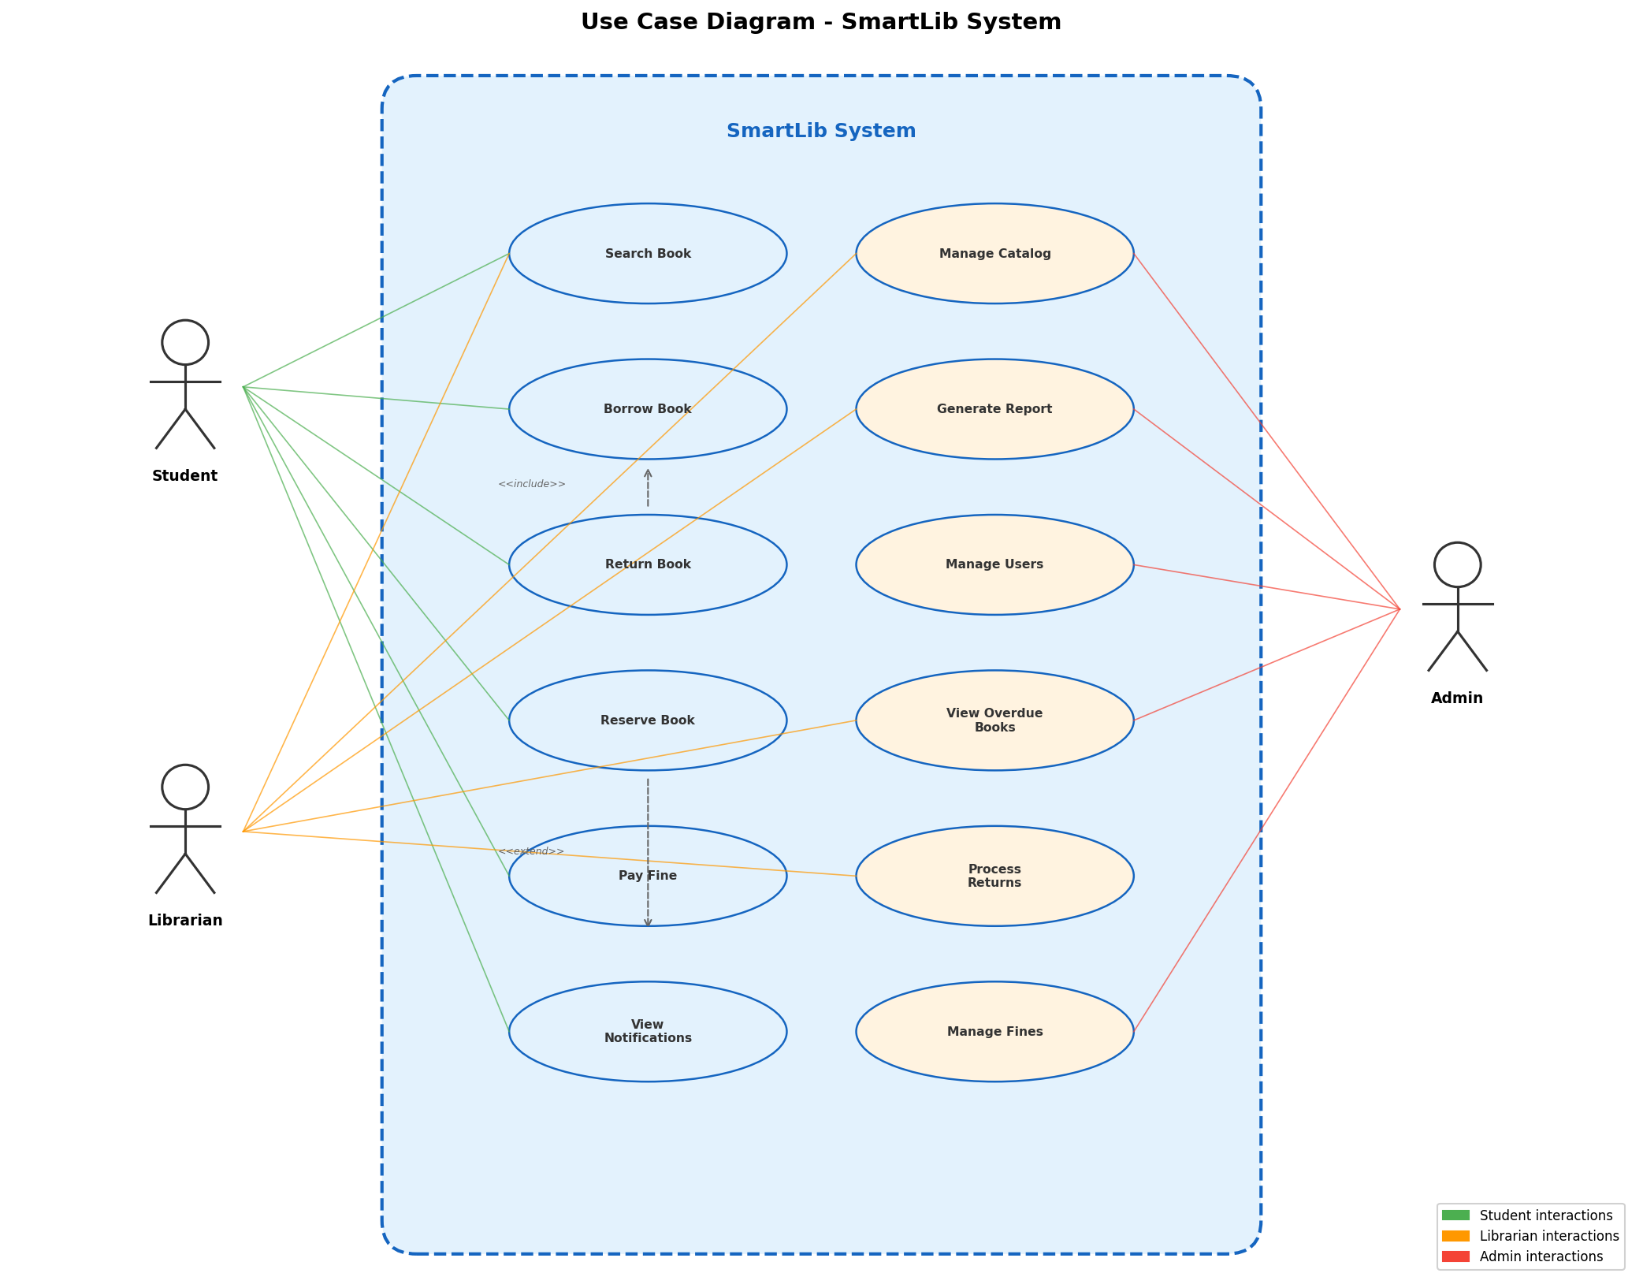
Figure 4: Use Case Diagram - SmartLib System

3.7.2 Activity Diagram - Borrow Book Process
The Activity Diagram models the dynamic behavior of the Borrow Book process, illustrating the sequence of activities, decision points, and parallel actions involved when a student borrows a book through SmartLib. The diagram uses swimlanes to distinguish activities performed by the Student from those performed by the SmartLib System. The process begins when the student logs in and searches for a book. The system then checks the book's availability. If the book is not available, the system displays a 'Not Available' message and the student may choose to reserve the book. If the book is available, the system checks the student's account status, including outstanding fines and borrowing limits. If the account has issues, an alert is displayed. If the account is valid, the student confirms the borrow request, the system processes the borrowing transaction, updates the database records (reducing available copies, recording the transaction with borrow and due dates), and sends a confirmation notification to the student. This activity diagram provides a clear, visual specification of the borrowing workflow that guides the development team's implementation.
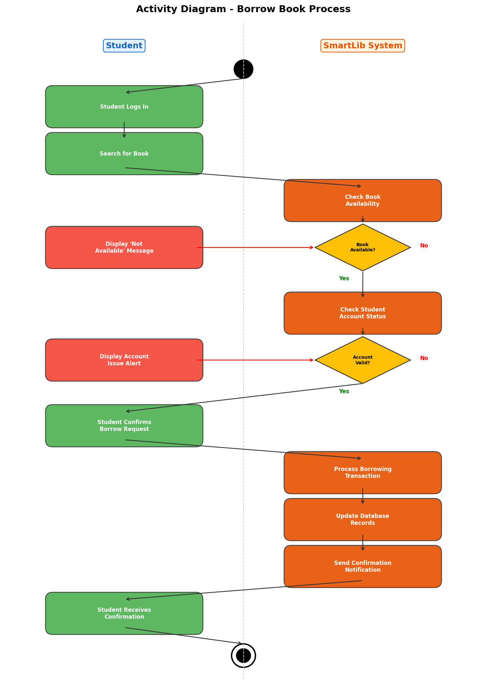
Figure 5: Activity Diagram - Borrow Book Process

4. Design
The design phase translates the analysis artifacts into detailed technical specifications that guide the system's implementation. This section presents the Entity Relationship Diagram that defines the database structure and the interface designs that specify the system's visual layout and user interaction patterns.

4.1 Entity Relationship Diagram (ERD)
The Entity Relationship Diagram defines the data model for the SmartLib database, identifying the key entities, their attributes, and the relationships between them. The database design follows third normal form (3NF) to minimize data redundancy and ensure data integrity. The primary entities in the SmartLib data model are:
User: Stores information about all system users including students, librarians, and administrators. Key attributes include UserID (primary key), Name, Email, Password (hashed), Role, Phone, Address, and Registration Date. The Role attribute enables role-based access control.
Book: Represents each unique title in the library's collection. Key attributes include BookID (primary key), ISBN, Title, Author, Publisher, Publication Year, Category (foreign key to Category entity), Total Copies, and Available Copies. The Available Copies count is updated automatically as books are borrowed and returned.
Category: Classifies books into subject categories for organized browsing and reporting. Attributes include CategoryID (primary key), Category Name, and Description.
Borrowing: Records each borrowing transaction. Key attributes include BorrowID (primary key), UserID (foreign key), BookID (foreign key), Borrow Date, Due Date, Return Date, and Status (Active, Returned, Overdue). This entity forms the core of the circulation tracking system.
Reservation: Tracks book reservations placed by students. Key attributes include ReservationID (primary key), UserID (foreign key), BookID (foreign key), Reserve Date, Expiry Date, and Status (Active, Fulfilled, Expired, Cancelled).
Fine: Records fines associated with overdue borrowing transactions. Key attributes include FineID (primary key), BorrowID (foreign key), Amount, Status (Unpaid, Paid, Waived), Payment Date, and Payment Method.
Notification: Stores notifications sent to users. Key attributes include NotifID (primary key), UserID (foreign key), Message, Type (Due Reminder, Overdue Alert, Reservation Available, etc.), Date Sent, and Is Read status.
The relationships between entities include: a User can have many Borrowings (one-to-many), a Book can appear in many Borrowings (one-to-many), a User can have many Reservations (one-to-many), a Book can have many Reservations (one-to-many), a Borrowing can have zero or one Fine (one-to-one or one-to-zero), a Category can contain many Books (one-to-many), and a User can receive many Notifications (one-to-many). These relationships ensure referential integrity and support the complex queries required by the reporting and analytics modules.
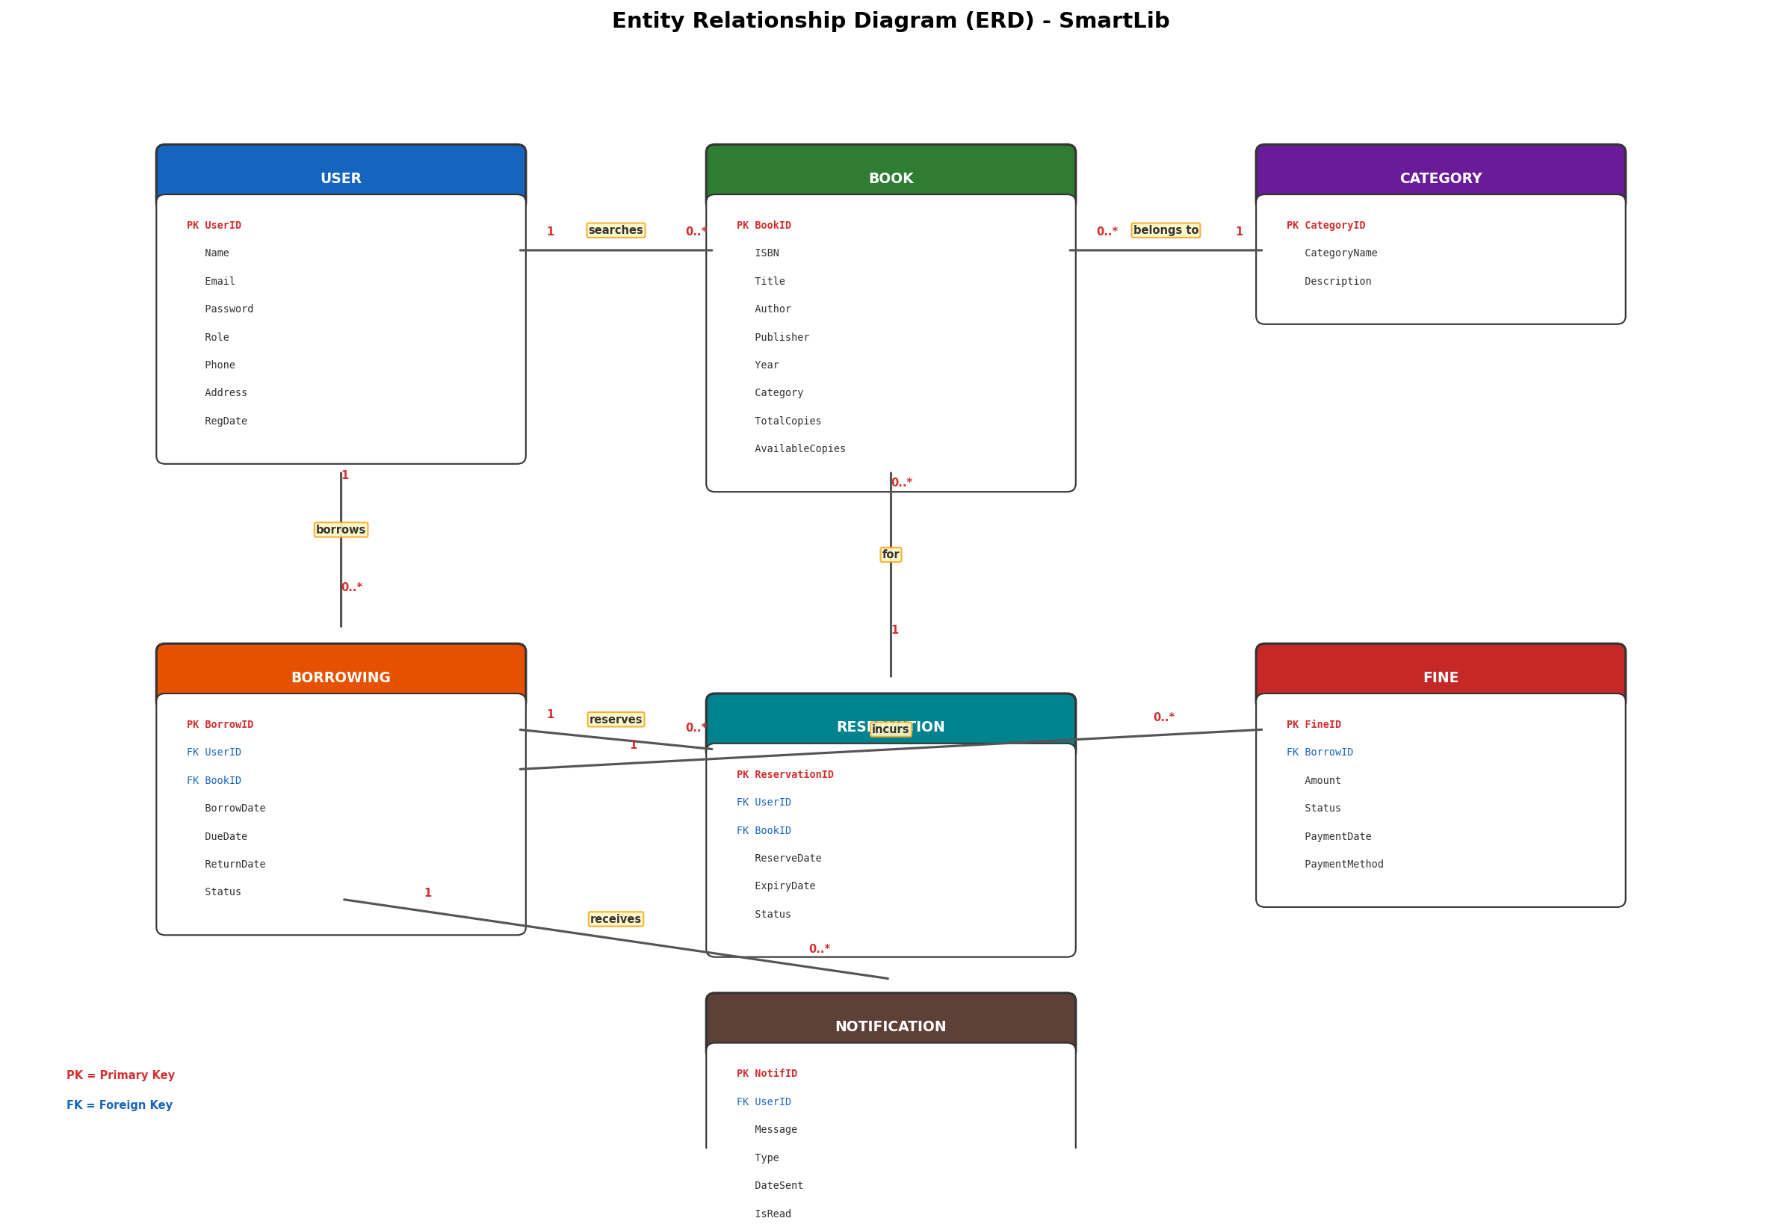
Figure 6: Entity Relationship Diagram - SmartLib Database

4.2 Interface Design
The interface design specifies the visual layout, navigation structure, and interaction patterns of SmartLib's user-facing screens. The design follows established usability principles including consistency, visibility of system status, user control and freedom, and recognition rather than recall. A clean, modern design language is adopted with a primary color palette of blue and white, complemented by green for success states, orange for warnings, and red for errors. The following mockups illustrate the key screens of the SmartLib application.

4.2.1 Login Page
The Login Page is the first screen users encounter when accessing SmartLib. It features a clean, centered login form with fields for Email Address and Password, along with a prominent Login button. The page includes links for Forgot Password recovery and New Account Registration. The SmartLib logo is displayed at the top of the form to establish brand identity. The design is intentionally simple to minimize friction for returning users while providing clear pathways for new users and those who need password assistance. Error messages for invalid credentials are displayed inline below the relevant field, and a loading indicator is shown during authentication to provide feedback on the login process.
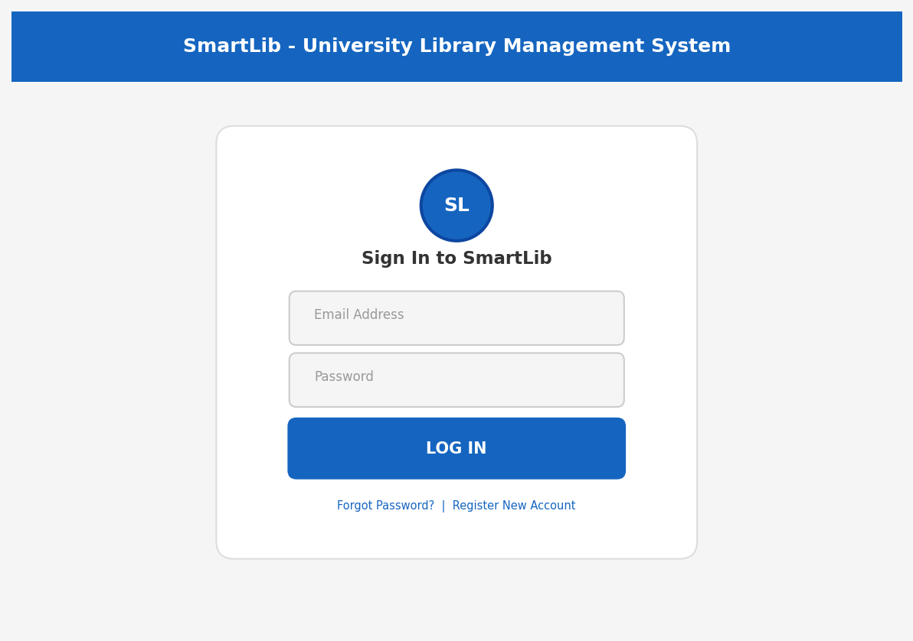
Figure 7: Login Page Mockup

4.2.2 Student Dashboard
The Student Dashboard serves as the primary landing page for authenticated students. The top navigation bar provides access to all major sections: Home, Catalog, My Books, Reservations, and Profile. Below the welcome message, four summary cards display key metrics at a glance: Books Borrowed, Books Overdue, Active Reservations, and Outstanding Fines. Each card uses color-coded indicators to draw attention to items requiring action. The main content area displays a table of Currently Borrowed Books showing the title, author, due date, and status of each book. A Quick Actions panel on the right provides one-click access to frequently used features such as Search Catalog, View Reservations, Pay Fines, and View History. This layout ensures that students can quickly assess their library status and take common actions without unnecessary navigation.
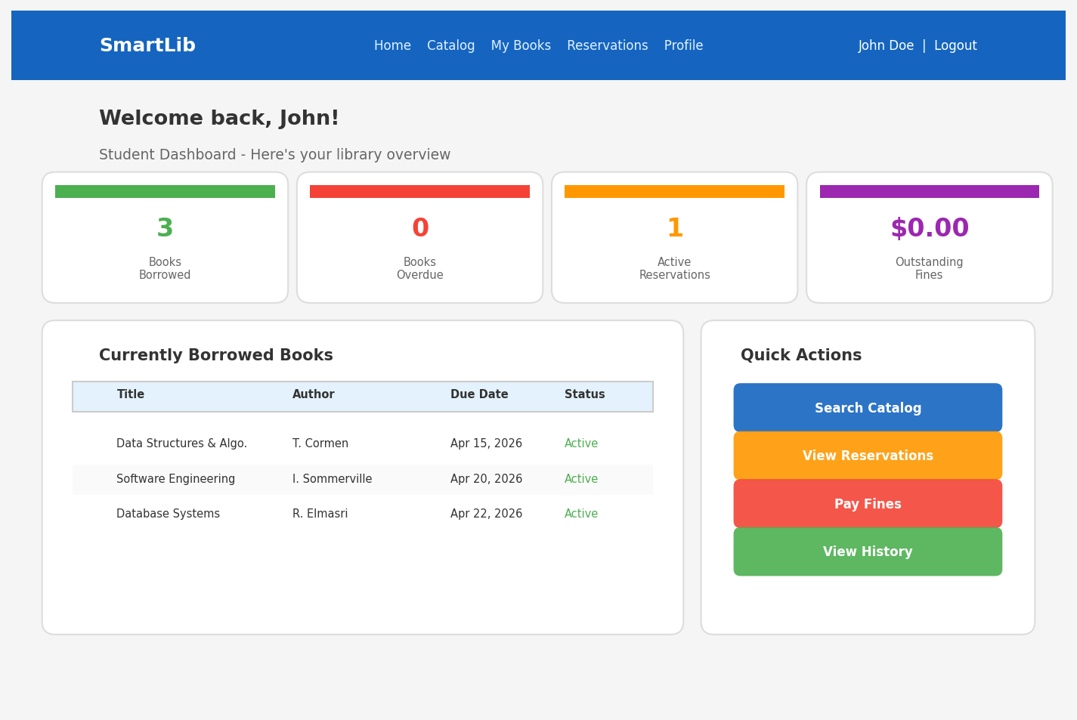
Figure 8: Student Dashboard Mockup

4.2.3 Book Search and Catalog Page
The Book Search and Catalog page provides a powerful and intuitive interface for browsing the library's collection. A prominent search bar at the top allows users to enter search terms, with a dropdown for selecting the search field (title, author, ISBN, or keyword). Below the search bar, filter chips allow users to narrow results by category, availability status, and sort order. Search results are displayed as cards, each showing the book's cover image (or a placeholder), title, author, category, and availability status. Available books display a green 'Available' badge and a 'Borrow' button, while borrowed books display a red 'Borrowed' badge with an option to reserve. The card-based layout provides a visually rich browsing experience that is scannable and efficient, allowing students to quickly identify the resources they need.
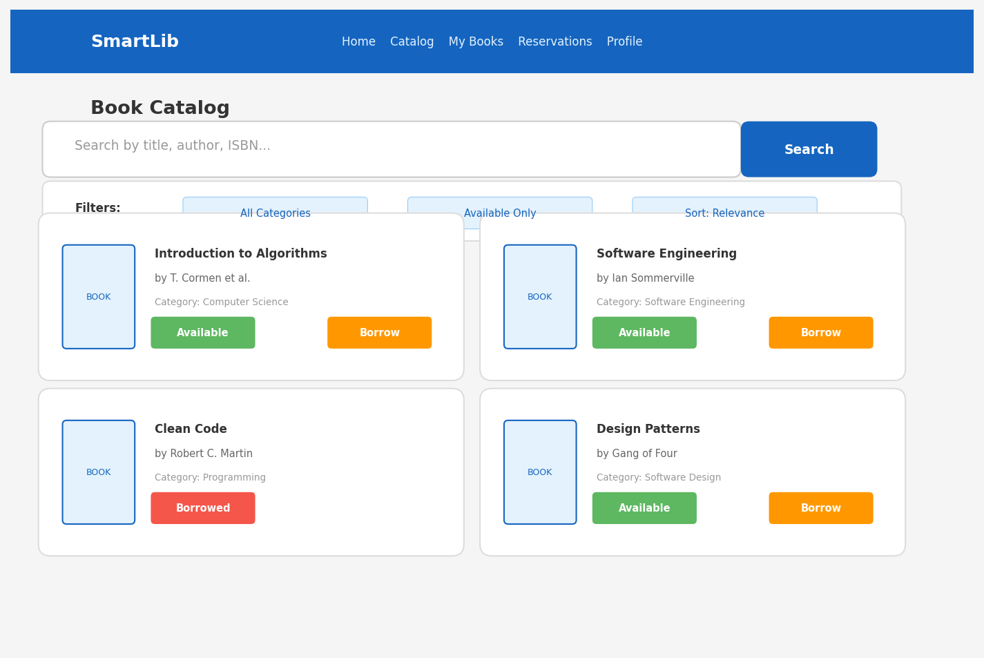
Figure 9: Book Search and Catalog Page Mockup

4.2.4 Book Details and Borrow Page
The Book Details page displays comprehensive information about a selected book. The left section features the book's cover image, while the right section presents detailed metadata including ISBN, publisher, publication year, category, total copies, available copies, and physical location within the library. The availability status is prominently displayed with a color-coded badge. Action buttons allow students to 'Borrow This Book' or 'Reserve' it, depending on availability. Below the details section, a Description area provides a summary of the book's content. This page gives students all the information they need to make an informed decision about borrowing or reserving a book, reducing the need for physical visits to inspect titles.
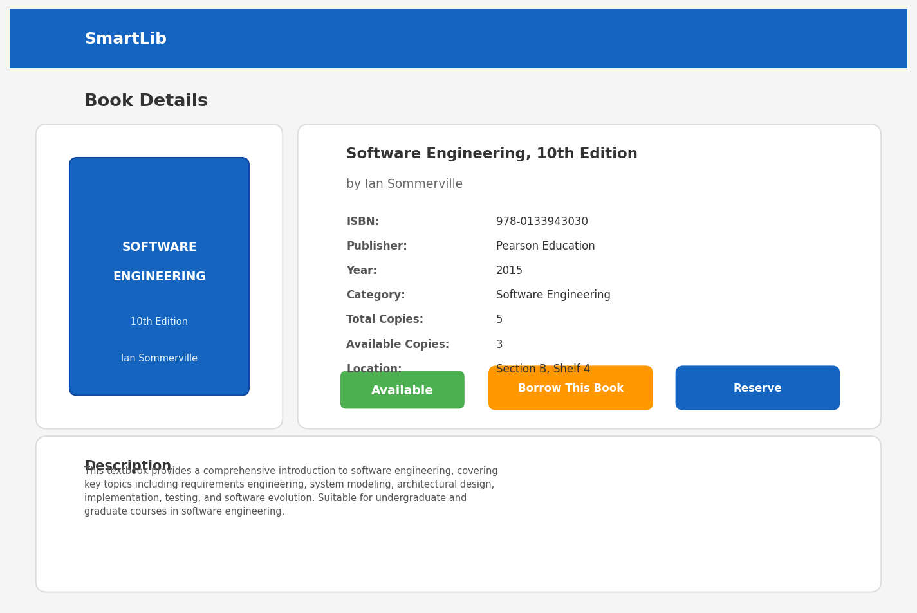
Figure 10: Book Details and Borrow Page Mockup

4.2.5 Admin Dashboard
The Admin Dashboard provides library administrators with a comprehensive overview of system operations and key performance indicators. The interface features a dark sidebar navigation menu for accessing all admin functions: Dashboard, Users, Books, Transactions, Fines, Reports, and Settings. The main content area displays four summary cards showing Total Users, Total Books, Active Borrows, and Monthly Revenue, each with trend indicators showing changes from the previous period. A Monthly Borrowing Trends chart visualizes circulation patterns over time, while a Recent Activity feed shows the latest system events in real time. A Quick Stats section at the bottom highlights actionable metrics including Overdue Books, Pending Reservations, Today's Returns, and System Uptime. This dashboard empowers administrators to monitor library operations at a glance and quickly identify areas requiring attention.
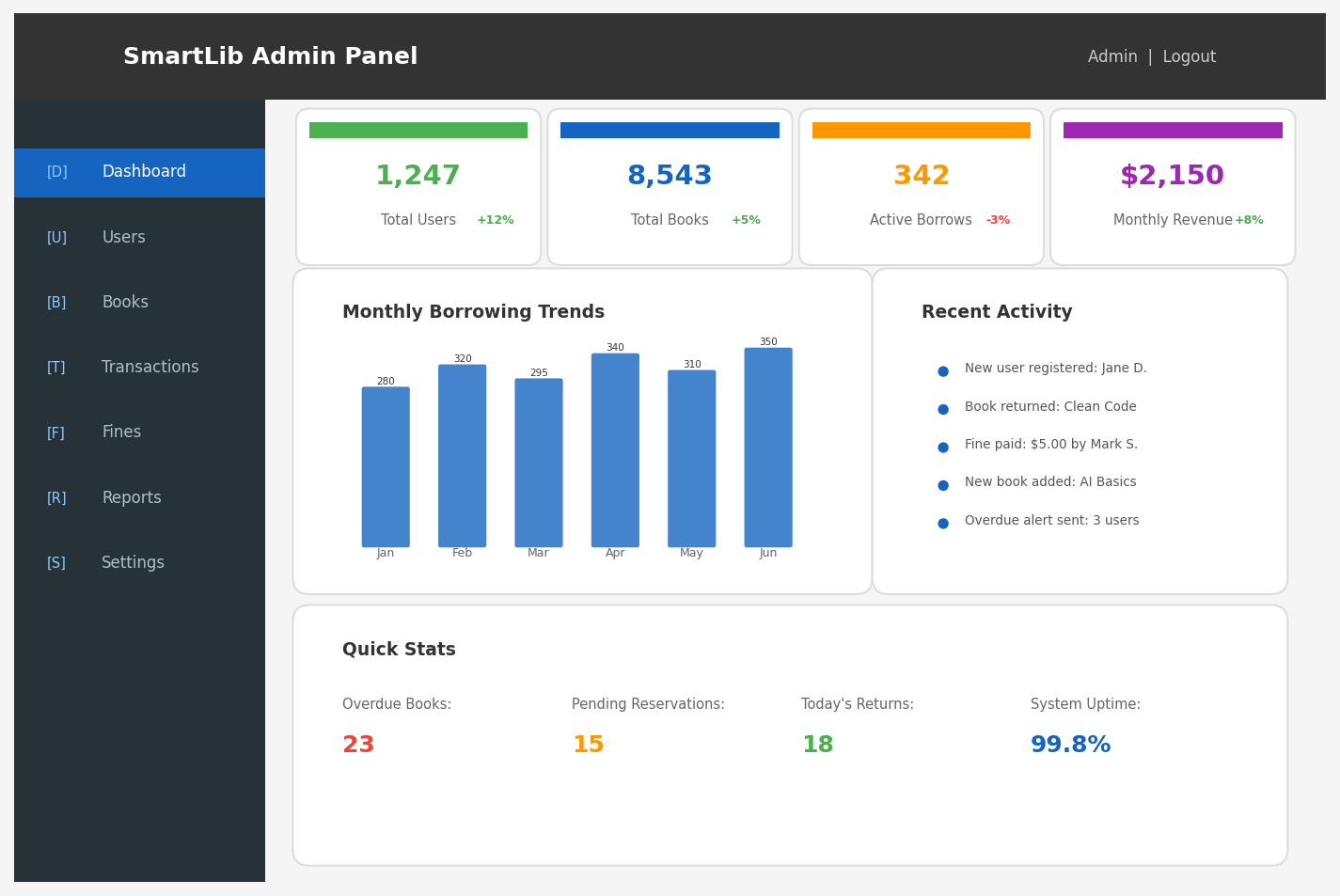
Figure 11: Admin Dashboard Mockup

4.2.6 Librarian - Manage Books Page
The Manage Books page provides librarians with tools for maintaining the book catalog. Action buttons at the top allow adding new books, importing data from CSV files, and exporting catalog data. A search bar enables quick lookup of specific books by title, author, ISBN, or category. The main content area displays a sortable and paginated table listing all books with columns for ID, Title, Author, ISBN, Total Copies, Available Copies, and Actions. The Available Copies column uses color coding: green for books with available copies and red for books that are fully borrowed. Each row includes Edit and Delete action links for managing individual records. Pagination controls at the bottom allow navigation through the full catalog. The interface is designed for efficiency, enabling librarians to manage large catalogs with minimal clicks and maximum visibility.
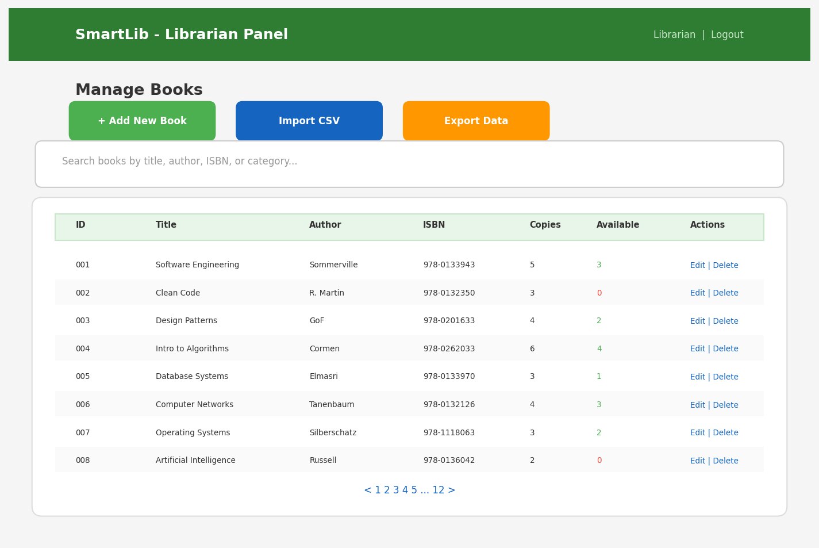
Figure 12: Librarian - Manage Books Page Mockup

5. Development
The development phase encompasses the actual construction of the SmartLib system, translating the design specifications into working software. This section documents the demo application built to demonstrate core features, the security measures implemented to protect the system and its users, and the backup and recovery plan designed to ensure data resilience and business continuity.

5.1 Demo Application
A functional demo application has been developed to showcase the core features and user interface of SmartLib. The demo application is built using a modern web technology stack consisting of HTML5, CSS3, and JavaScript on the front-end, with a Node.js/Express.js back-end and a MySQL database. The React.js library is used for building the user interface components, and Tailwind CSS provides the styling framework. The demo implements the following key features:
- User registration and authentication with role-based access control (Student, Librarian, Admin)
- Book catalog browsing with real-time search, filtering, and availability display
- Book borrowing workflow with account validation, availability checking, and transaction recording
- Book returning process with automatic fine calculation for overdue items
- Reservation system with queuing and automatic notification on availability
- Student dashboard with borrowed books, fines, and reservation summaries
- Admin dashboard with system metrics, charts, and recent activity feed
- Librarian catalog management interface with CRUD operations and bulk import
- Notification system with email and in-app alerts for due dates and overdue items
The following screenshots demonstrate the demo application running in a web browser, showcasing the home page, catalog browsing interface, and the student's borrowed books management page.
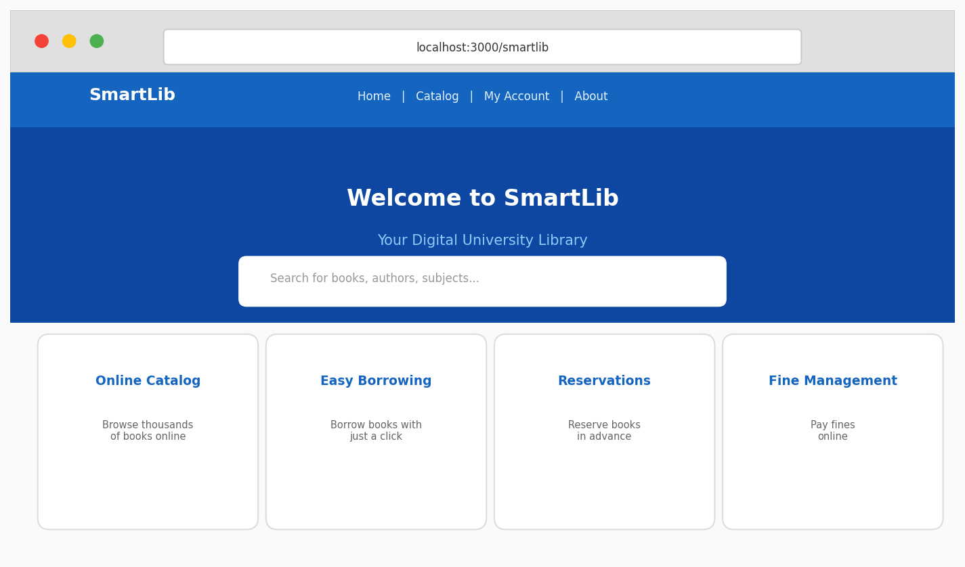
Figure 13: SmartLib Demo - Home Page
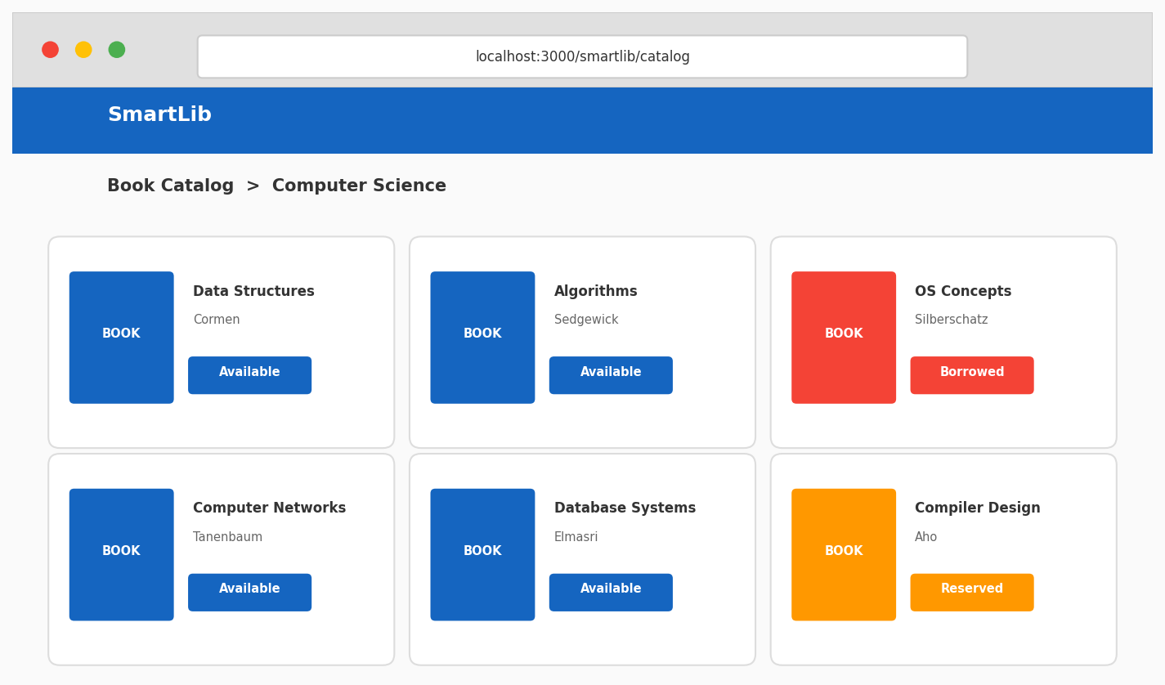
Figure 14: SmartLib Demo - Book Catalog Page
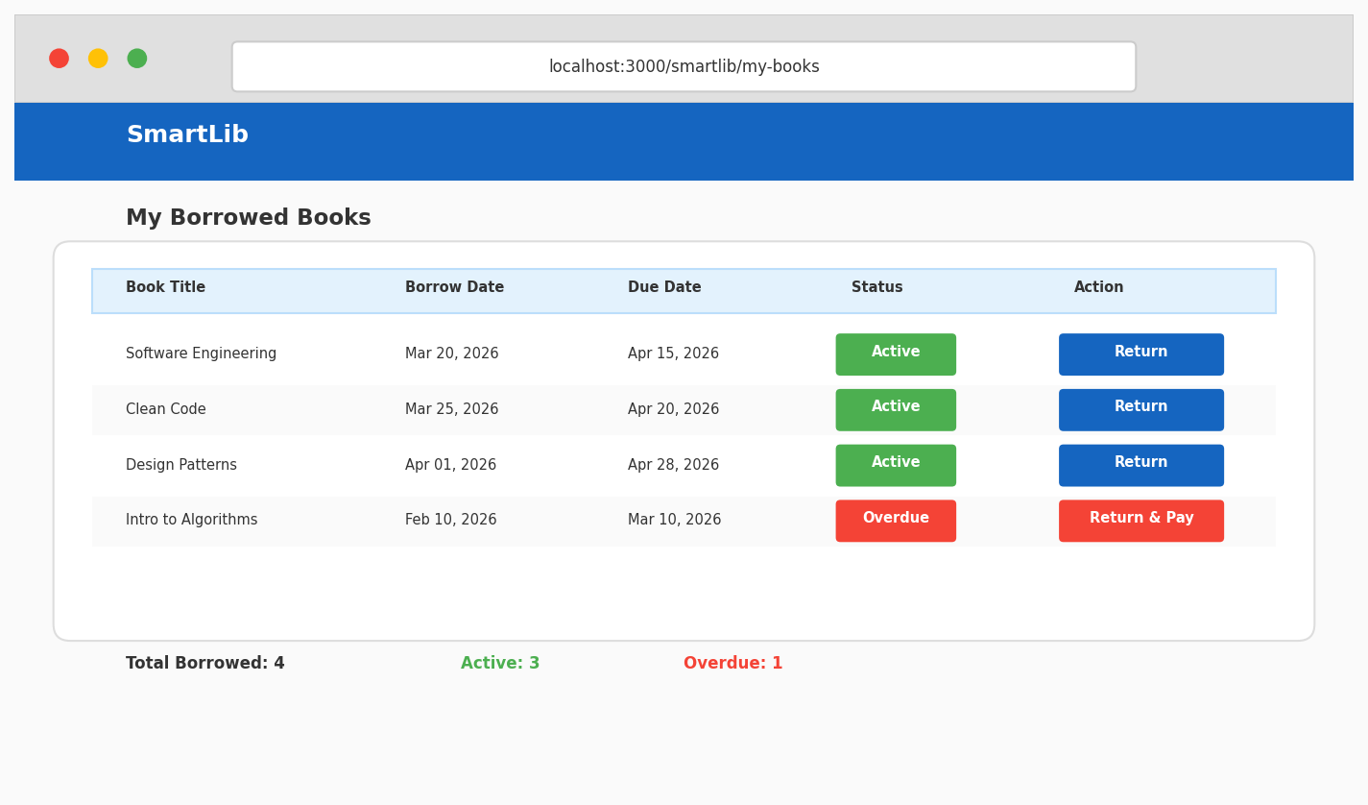
Figure 15: SmartLib Demo - My Borrowed Books Page

5.2 System Support and Security
Security is a paramount concern for SmartLib, as the system handles sensitive personal information, academic records, and financial transactions. A defense-in-depth approach has been adopted, implementing multiple layers of security controls to protect the system against a wide range of threats. The following security measures have been implemented:

Authentication and Password Security
User authentication is implemented using JSON Web Tokens (JWT) for stateless, scalable session management. All user passwords are hashed using the bcrypt algorithm with a work factor of 12, ensuring that even if the database is compromised, passwords cannot be easily reversed. The system enforces password complexity requirements including a minimum length of 8 characters, at least one uppercase letter, one lowercase letter, one digit, and one special character. Account lockout is triggered after five consecutive failed login attempts, with an automatic unlock after 30 minutes. Password reset functionality uses time-limited, single-use tokens sent to the user's registered email address.

Authorization and Role-Based Access Control (RBAC)
The system implements role-based access control with three defined roles: Student, Librarian, and Admin. Each role is assigned a specific set of permissions that determine which resources and actions are accessible. Authorization checks are enforced at both the front-end (hiding unauthorized UI elements) and the back-end (middleware validation of JWT claims against required permissions for each API endpoint). This dual-layer approach prevents unauthorized access even if a user attempts to bypass front-end restrictions by directly calling API endpoints.

Data Encryption
All data transmitted between the client browser and the SmartLib server is encrypted using Transport Layer Security (TLS) version 1.3, the latest and most secure version of the protocol. SSL certificates are obtained from a trusted Certificate Authority and are automatically renewed. Sensitive data at rest in the database, including email addresses and payment information, is encrypted using AES-256 encryption. Database backups are also encrypted to protect data in storage.

Input Validation and Sanitization
All user inputs are validated on both the client side and the server side to prevent malformed data from entering the system. Server-side validation uses schema validation libraries to enforce data type, length, format, and range constraints for every input field. Input sanitization removes or escapes potentially dangerous characters to prevent injection attacks. File uploads, such as CSV imports for bulk book data, are validated for file type, size, and content before processing.

SQL Injection Prevention
The system uses parameterized queries and prepared statements for all database interactions, completely eliminating the risk of SQL injection attacks. The database access layer is built using an ORM (Object Relational Mapping) library that automatically parameterizes queries. Direct string concatenation in SQL queries is strictly prohibited in the coding standards and flagged during code reviews.

Cross-Site Scripting (XSS) Prevention
The React.js framework provides built-in XSS protection by automatically escaping all rendered content. Additionally, Content Security Policy (CSP) headers are configured to restrict the sources from which scripts, styles, and other resources can be loaded. HTTP-only and Secure flags are set on all cookies to prevent client-side script access and ensure cookies are only transmitted over HTTPS connections.

Regular Security Audits and Monitoring
The system undergoes regular security assessments including automated vulnerability scanning using tools such as OWASP ZAP and dependency checking using npm audit. Security patches for dependencies are applied promptly. Application logs are monitored for suspicious activities such as repeated failed login attempts, unusual data access patterns, and privilege escalation attempts. An intrusion detection system (IDS) monitors network traffic for known attack signatures. The development team follows the OWASP Top Ten guidelines as a baseline for secure development practices.

System Monitoring and Health Checks
Application performance monitoring is implemented to track response times, error rates, and resource utilization in real time. Automated health check endpoints verify the availability of critical system components including the web server, database, email service, and payment gateway. Alerting rules are configured to notify the operations team via email and SMS when performance metrics exceed defined thresholds or when component failures are detected. Server logs are aggregated and analyzed for operational insights and troubleshooting.

5.3 Backup and Recovery Plan
A comprehensive backup and recovery plan has been developed to protect SmartLib's data against loss due to hardware failure, software errors, human mistakes, security breaches, or natural disasters. The plan defines backup procedures, recovery objectives, and testing schedules to ensure business continuity and data resilience.

Backup Strategy
Daily Incremental Backups: Automated incremental backups are performed every day at 2:00 AM during off-peak hours. Incremental backups capture only the changes made since the last backup, minimizing backup duration and storage requirements. Daily backups are retained for 30 days on a rolling basis.
Weekly Full Backups: A complete full backup of the entire database and application files is performed every Sunday at 1:00 AM. Full backups capture the complete state of the system, providing a reliable restore point. Weekly backups are retained for 12 weeks.
Monthly Off-Site Backups: On the first day of each month, a full backup is transferred to a geographically separate off-site storage facility using encrypted transfer protocols. Off-site backups protect against site-level disasters such as fire, flood, or infrastructure failure. Monthly backups are retained for 12 months.
Real-Time Transaction Logging: Database transaction logs are maintained continuously, recording every write operation to the database. These logs enable point-in-time recovery, allowing the system to be restored to any specific moment within the retention period.

Recovery Objectives
Recovery Time Objective (RTO): The maximum acceptable downtime for SmartLib is 4 hours. This means that in the event of a system failure, full service must be restored within 4 hours. This RTO is achievable given the combination of automated backups, documented recovery procedures, and standby infrastructure.
Recovery Point Objective (RPO): The maximum acceptable data loss is 1 hour. This means that, in a worst-case scenario, the system may lose up to 1 hour of data from the most recent transactions. The combination of daily incremental backups and real-time transaction logging ensures that the actual data loss will typically be far less than 1 hour.

Disaster Recovery Procedures
A documented disaster recovery procedure is maintained and updated quarterly. The procedure outlines step-by-step instructions for restoring the system from various failure scenarios:
- Database corruption or failure: Restore from the most recent daily backup and apply transaction logs to recover to the point of failure.
- Application server failure: Deploy a fresh application instance from the Docker container image and connect to the database. Stateless architecture ensures no session data is lost.
- Complete site failure: Activate the off-site backup, provision new infrastructure, restore the most recent monthly backup, apply subsequent weekly and daily incremental backups, and apply transaction logs to minimize data loss.
- Data breach recovery: Isolate the compromised system, perform a forensic analysis to determine the scope of the breach, restore from a clean backup taken before the breach occurred, apply security patches, reset all user credentials, and notify affected users.

Backup Testing Schedule
Backups are only valuable if they can be successfully restored. The following testing schedule ensures the reliability and integrity of the backup strategy:
Monthly: A test restore of the most recent daily incremental backup is performed in a staging environment to verify backup integrity and the restoration procedure.
Quarterly: A full disaster recovery drill is conducted, simulating a complete site failure. The team practices restoring the entire system from off-site backups within the RTO target.
Annually: A comprehensive review of the backup and recovery plan is conducted, incorporating lessons learned from the quarterly drills and any changes in the system's architecture or data volume.

6. References
Sommerville, I. (2015). Software engineering (10th ed.). Pearson Education. ISBN: 978-0133943030.
Pressman, R. S., & Maxim, B. R. (2020). Software engineering: A practitioner's approach (9th ed.). McGraw-Hill Education. ISBN: 978-1259872976.
Schwaber, K., & Sutherland, J. (2020). The Scrum guide: The definitive guide to Scrum: The rules of the game. Scrum.org. https://scrumguides.org/scrum-guide.html
Dennis, A., Wixom, B. H., & Roth, R. M. (2018). Systems analysis and design (7th ed.). John Wiley & Sons. ISBN: 978-1119496489.
Elmasri, R., & Navathe, S. B. (2016). Fundamentals of database systems (7th ed.). Pearson Education. ISBN: 978-0133970777.
Fowler, M. (2003). UML distilled: A brief guide to the standard object modeling language (3rd ed.). Addison-Wesley Professional. ISBN: 978-0321193681.
Bass, L., Clements, P., & Kazman, R. (2021). Software architecture in practice (4th ed.). Addison-Wesley Professional. ISBN: 978-0136885979.
OWASP Foundation. (2021). OWASP Top Ten - 2021: The ten most critical web application security risks. https://owasp.org/www-project-top-ten/
Koha Library Software Community. (2024). Koha library management system documentation. https://koha-community.org/documentation/
International Federation of Library Associations and Institutions (IFLA). (2023). Guidelines for online public access catalogue (OPAC) displays. https://www.ifla.org/publications/
React.js Documentation. (2024). React: A JavaScript library for building user interfaces. Meta Platforms. https://react.dev/
Node.js Foundation. (2024). Node.js documentation. OpenJS Foundation. https://nodejs.org/en/docs/

